Greetings,  
Thank you for showing interest in the **React Native Developer** position at Monova. Below is your assignment for this round.

Once complete, **fill this Tally form** for submission:https://tally.so/r/wvRzad

**Goal**Recreate the **exact UI/interaction flow** demonstrated in our reference video below using **Expo Snack (React Native Web)**. Your app should be visually faithful and functionally equivalent on the web.

You are *not* required to build backend logic. Use mocked data and client-side state. Focus on **pixel-accuracy, interactions, and smooth animations**.  
  
Video - [Reference Video](https://drive.google.com/file/d/1ODMrTiZ-nkxBbTEUMr16LcYLuYMn5vVB/view?usp=sharing)  
  
Also, adding some Screenshots for reference-  
  
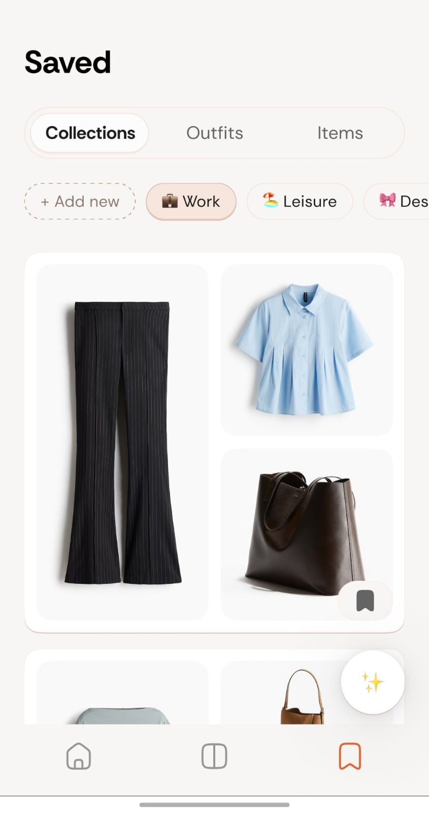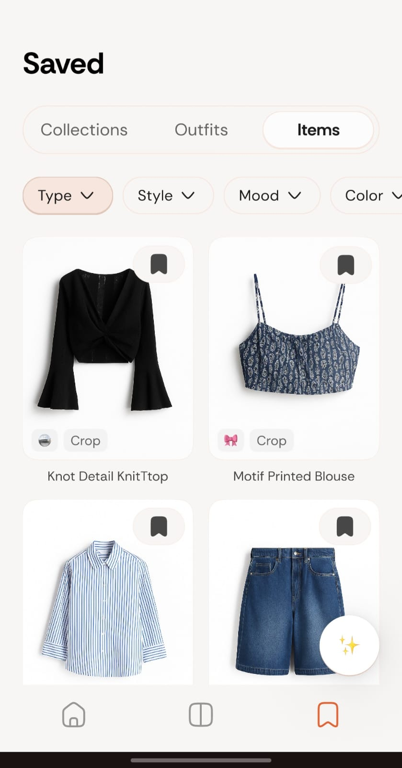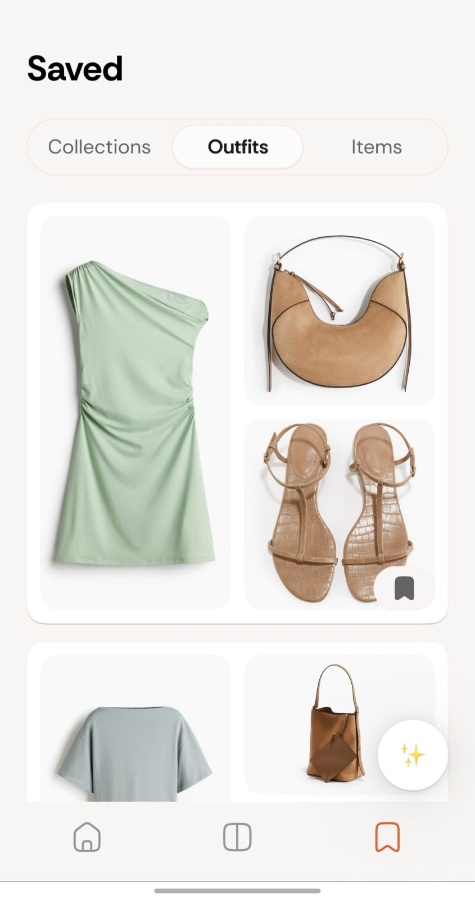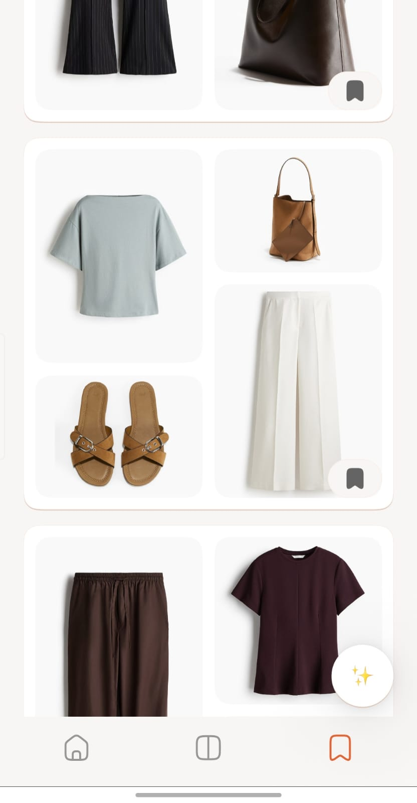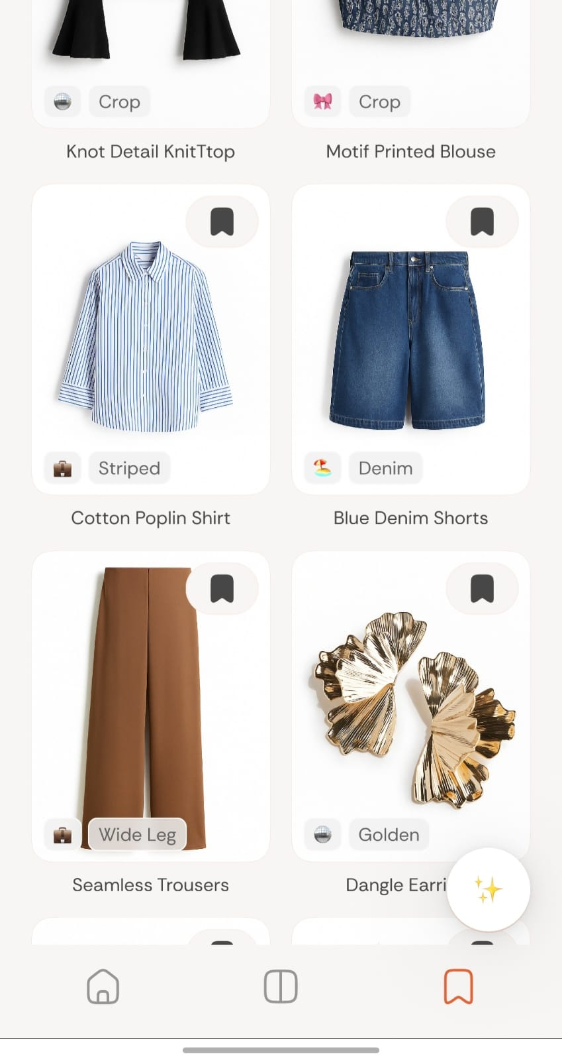

## **Scope (Build what you see in the video)**

Build these screens/components to mirror the reference

1. **Items Preview**
   * Grid/list of items with image, category, color, style badges.
   * Filter chips and active-filter pills (reflect selections in real time).
   * Empty / loading placeholders.
2. **Outfit and collections**
   * Scrollable cards.
   * Each card shows Top + Bottom + Footwear (+ optional Outerwear image tiles), title, and tag chips.
   * Swipe/scroll transitions as in video (springy, not janky).

## **Visual & Interaction Requirements**

* **Pixel fidelity**: match layout spacing, typography scale, card shapes, and chip styles you see in the video.
* **Animations**: smooth entrance for cards, micro-interactions on chip toggles, and a subtle carousel transition.
* **Responsive**: works on typical mobile resolution.
* **Accessibility**: logical tab order, pressable hit areas ≥44px.

## **Tech Constraints**

* **Expo Snack** (target: **web** via React Native Web).
* **TypeScript** preferred.
* **Navigation**: simple stack or tabs is fine (expo-router optional)..
* **Data**: hardcode a small JSON inventory (10–30 items) and user/occasion presets.

## **Acceptance Criteria (what we’ll check)**

* UI and flow **visually match** the reference video screens.
* Filters and chips update the inventory/outfit cards client-side.
* Carousel/scroll behavior feels **buttery** (no layout jumpiness).
* Clean code structure and clear components.

## **Deliverables**

1. **Expo Snack URL** (runs on web).
2. **Public GitHub repo** with the same codebase.  
   * **README.md** including:  
     + How to run (Snack link),
     + What you replicated from the video,
     + Component structure & state management,
     + Assumptions and limitations,
     + List of animations/interactions implemented.
3. Submit both the links by filling the form : https://tally.so/r/wvRzad